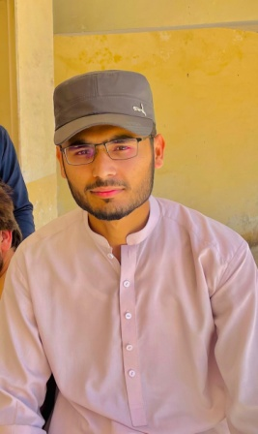**Abdal Hussain**

Address: Tarnab Farm, Peshawar, Pakistan

Contact No: 0318-7729697

Email: [abdalhussain5790@gmail.com](mailto:abdalhussain5790@gmail.com)

**OBJECTIVE**

I am enthusiastic about seeking an internship in Frontend Development in your company where I can kick start my career and build a valuable skill set.

**EDUCATION**

|  |  |
| --- | --- |
| **Description** | **Institutes** |
| Present: Undergraduate CS Student in 5th Semester | Abdul Wali Khan University Mardan |
| Intermediate (Computer Science) | Govt College Peshawar |
| Matriculation | Govt Shaheed Arham Khan Higher Secondary School |

**SKILLS**

* HTML
* CSS
* JavaScript (Learning)
* Git & Github
* Graphic Design (Basic)
* C++ (Basic)
* Java (Basic)

**WORK EXPERIENCE**

* Data Entry Operator and Accounts Assistant at Mushtarika Petroluem Pvt Ltd. from Aug 2020 to Oct 2021.
* Again selected and working (part time) since Sep 2024 as a Data Entry Operator and Accounts Assistant at Mushtarika Petroluem Pvt Ltd.

**PERSONAL INFORMATION**

|  |  |
| --- | --- |
| Father Name: | Muhammad Hussain |
| Date of Birth: | 05/03/2024 |
| CNIC No: | 17301-8073410-9 |
| Gender: | Male |
| Nationality: | Pakistani |
| Religion: | Islam |

**Reference:**

On demand of Dr. Liaqat Ali.